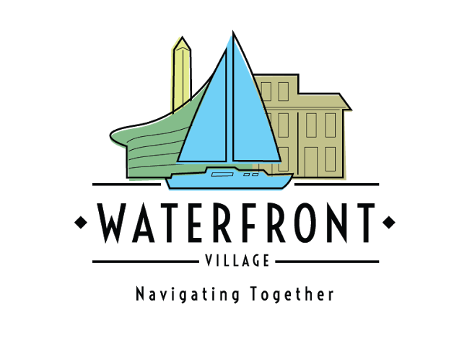

Waterfront Village
Annual Report
2023

February 15, 2024

A MESSAGE FROM THE PRESIDENT

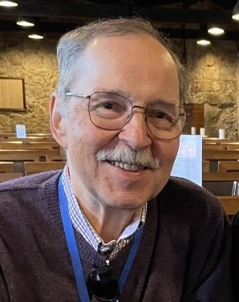
I’m delighted to share the Waterfront Village Annual Report for 2023. It was a great year for us. We can look back with satisfaction on the many ways in which the Village accomplished its mission of providing both vital services to members and programs that enriched our lives.
For our members, the Village is a solution to what the Surgeon General has called “the public health crisis of loneliness, isolation, and lack of connection in our country.” Village activities and events are a wonderful way to keep active, stay informed, make friends, and have some fun. Throughout 2023, our superb staff continued to expand the variety and quality of our programs.
The Village couldn’t operate without volunteers to provide services, help with events, or participate in committees. We’re an organization of neighbors helping neighbors; we can succeed only if our members exhibit a spirit of volunteerism. I want to offer my personal thanks to those who have volunteered in any capacity, and to encourage all our members to volunteer in some way. Our generous donors, including individual members, the DC government, foundations, and community groups, were also crucial to our success during the year.
The end of 2023 marked an important transition for the Village. After many years of service, both board president Carroll Quinn and executive director Len Bechtel stepped down from their positions. Carroll continues to serve as a non-voting board member in her capacity as president emerita. Len and Carroll deserve our deep gratitude for all they accomplished for the Village and its members. Looking ahead, our new executive director, Pam Troutman, and I, as well as the entire board of directors, are committed to ensuring that Waterfront Village will prosper and will continue to improve its work on behalf of our members and our community.
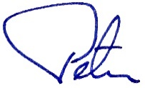
Sincerely,

Peter Eicher,
President

2023: A YEAR IN REVIEW
Membership

Village membership remained steady; as of December 31, 2023, there were 210 members. This year, 39 new members joined and we said goodbye to 32 members. The majority of new members were supporting members (31), who joined to participate in our programs and to connect with neighbors and made fewer requests for services. Most members who did not renew included members who passed away, members who relocated, or those who became too ill to participate in our programs. We are grateful to Friends of Southwest DC, which supported our subsidized membership program this year; this program supported memberships for 17 people over the course of the year. The Village distributed our annual member survey in late summer. 82 members responded to the survey; 98% of responding members reported that they were satisfied or very satisfied with Village staff. Satisfaction with programs, activities, and events was reported by 90% of respondents.

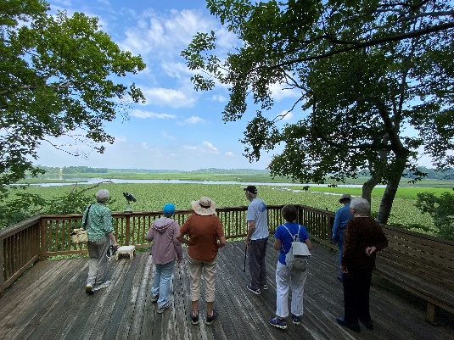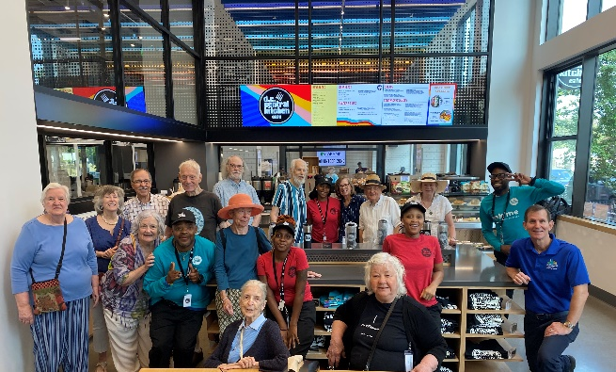
Villagers at Jug Bay Members tour DC Central Kitchen

Services

During 2023, 866 services were provided to members. This is a slight decrease from the previous year, primarily due to the influx of new supporting members as opposed to full members. Members were provided with 302 telephone check-ins or friendly visits, 167 rides to medical appointments, and 93 tech support services. We also provided information and referral services, family support, medical system navigation and advocacy services 123 times. This speaks to the complexity of the system and the need for Village staff to stay informed about local service providers and resources. It also highlights the importance of our volunteers, who provided many of these services.

Of our 210 members, 127 received at least one service, 14 members received 10 or more services, and 12 members received 20 or more services. The Village continues to provide critical support for members who are experiencing health crises and who may have limited social support networks available locally.

In addition, 21 people who attended the Solo Aging class were provided with an up-to-date resource list that identified providers who could assist with everything from bill and paperwork management to laundry services to legal advice. (All members can contact Village staff for referrals in any of the areas.) More importantly, the class provided a time and place for people to have some critical conversations about their future plans.

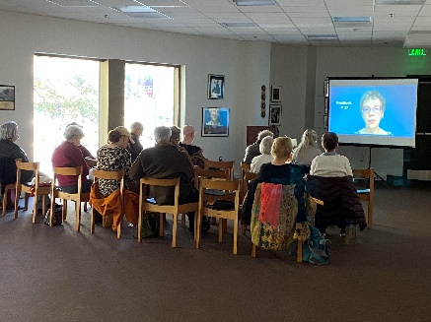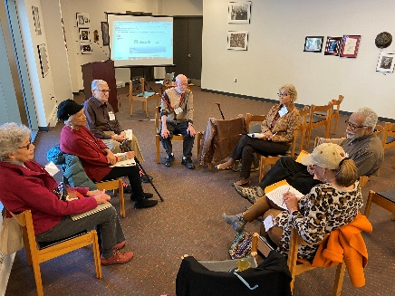
Solo Aging Class Solo Aging discussion

While we do not yet have hard data on services that members provide one another outside of the Village processes, there are many occasions when members exchange care and support with one another based on friendships that started at the Village. Whether it is driving a friend to the bank, picking up a prescription, or calling to check-in on a fellow member who is ill, there is no doubt that Village membership begets significant care beyond what our data currently tracks.

Programs

In 2023, our online calendar listed 415 events; all but a very few were Village-run events. Walking clubs gathered weekly with a newly added 30-minute walking group. Member-led groups included the Book Club and two new groups: Meditation and Great Decisions, a current events group. Our online registration system recorded over 1,900 separate registrations by 228 unique individuals.

Arts programming continued to be a favorite. From Southwest Chamber Player Concerts, to a docent/Village member-led tour of the Freer Gallery, to Evita and Here There are Blueberries at the Shakespeare Theatre Company, to an eight-session painting class, the arts brought many Village members together and welcomed many new members. We are grateful to our partnerships with the Shakespeare Theatre Company and a grant from the Southwest Community Foundation that made some of these programs possible. A highlight of our spring programming was our Inaugural Art Exhibit, Art of Ages; 15 older artists of SW DC participated in this event and the talent amongst our membership was something to remember.

In March we hosted a Safety in Southwest forum, co-sponsored by St. Matthew Church, with guests from the Police Department, the Department of Aging and Community Living, the Department of Insurance, Securities, and Banking, and Council Member Charles Allen.

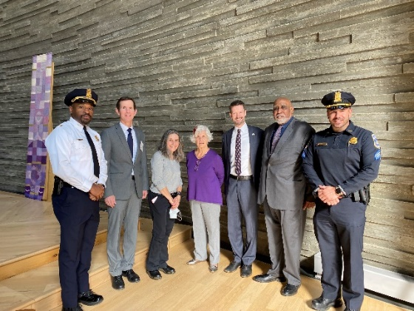
Village Safety Forum, with guests including Council Member Charles Allen, representatives from DCPD, DACL, and the Department of Insurance, Securities, and Banking

Other programs included our annual Anniversary and Awards lunch at Masala Arts and, at the end of August, our second Senior Celebration Week, which included a peach festival, a guest speaker (journalist Paul Orgel), a trip to Planet Word, and a chamber music concert. Our annual BBQ and Home Expo participants enjoyed perfect weather in September, and we were pleased to welcome a wide range of vendors and service providers for members to meet. Our Home Tour in October was another hit, with many members coming out to volunteer. In December we celebrated the holidays and the retirement of Executive Director Len Bechtel, with over 90 members in attendance. And these are just some examples of the many programs sponsored by the Village.

While these programs are enriching and fun in their content, the gatherings also provide a critical opportunity for members to get to know one another and make connections, part of the Village effort to combat social isolation.

Village Staff Update

Executive Director Len Bechtel retired on December 29, 2023 after four years of outstanding service. He has our heartfelt thanks. The Village remains in good hands, as our outstanding former Assistant Director, Pam Troutman, stepped up to become Executive Director in January 2024. A new Assistant Director, Patricia Johnson, joined the staff on December 1 and brings extensive experience in serving her community to the Village.

DC Village Collaborative

This year brought about a formal cooperation agreement among the District’s thirteen Villages, now referred to as the DC Village Collaborative (DCVC). Waterfront Village leadership has met for many years with leaders of other villages, but this formal arrangement will hopefully produce additional funding, more shared programs, and provide improved outreach efforts for all of the Villages. In early 2024, the new DCVC Executive Director, Dr. Katt Polk, will come on board.

TREASURER’S REPORT
In 2023, Waterfront Village continued to pursue and implement efforts to practice good stewardship and economize. The year ended with the Village on a sounder financial footing that it began.
Revenue for 2023 came to $235,071, an increase of $9,067 over 2022. Expenses for 2023 came to $203,556, an increase of $2,371. Thanks to careful controls and cost-saving efforts by staff, expenses fell below budget by approximately $26,000. The Village experienced a net revenue of $32,124; additional grant income accounted for much of this revenue. As a result, the Village was able to continue to solidify its reserves. Building a reserve fund is a tough challenge for a relatively new organization such as the Village, but is crucial for financial security and sustainability for the future, particularly given the uncertainties of continuing grants from the DC government and foundations.
Individual donations decreased from $62,119 to $54,307. Membership increased slightly, resulting in higher income from membership dues and grant income came in above budget as well. The Home Tour remains the most important fundraising event for the Village, bringing in $22,983, while the spring inaugural Art Exhibit brought in additional revenue and has been identified as a future source of additional revenue for the Village.
The Village is grateful for the support of the DC Department of Aging and Community Living, The Washington Home Foundation, Friends of Southwest DC, and the Southwest Community Foundation for their ongoing support. We were please to offer some new programming and other benefits thanks to these grantors. We also enjoyed a partnership with the Shakespeare Theatre Company, which provided complimentary tickets for two shows this year, a total of 80 tickets.
2023 Financial Summary
Revenue |  | Expenses
Membership Dues | 57,036 | Programs and Ops. | 24,069
Grants | 93,660 | Payroll and Benefits | 140,792
Donations | 36,631 | Facilities and Equip | 21,118
Board Support | 18,676 | Professional Services | 16,251
Fundraising Events | 22,983 | Fundraising | 1,326
Other Income | 6,301
TOTAL | 235,710 | TOTAL | 203,556
Sincerely,
Judith Winston
Treasurer
DONORS, SUPPORTERS, AND VOLUNTEERS
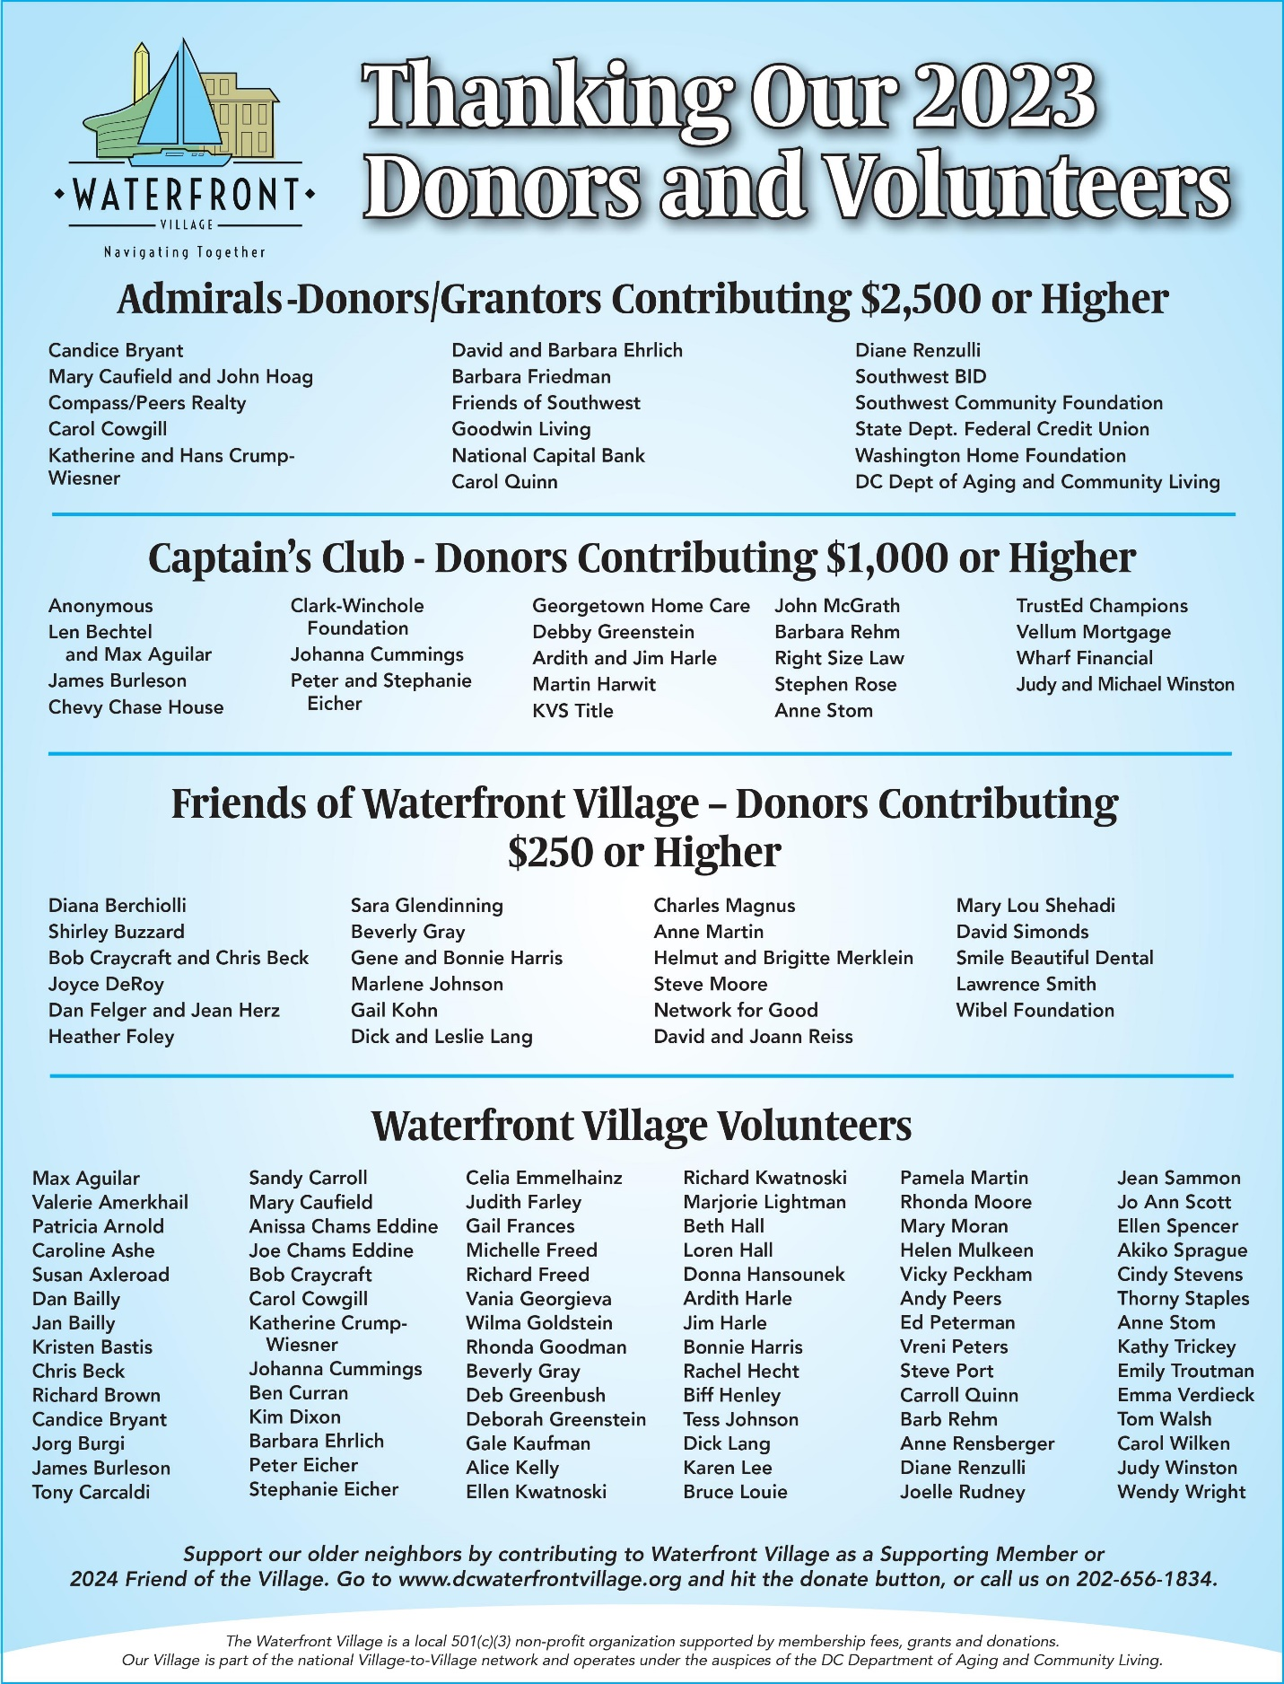

AWARDS

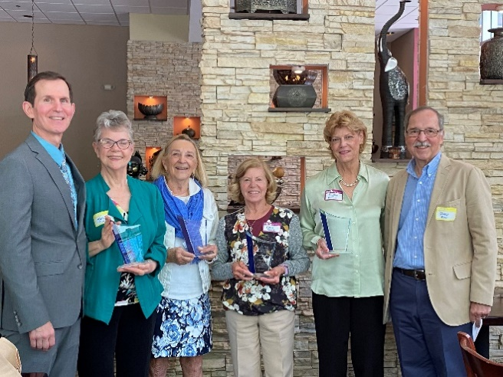
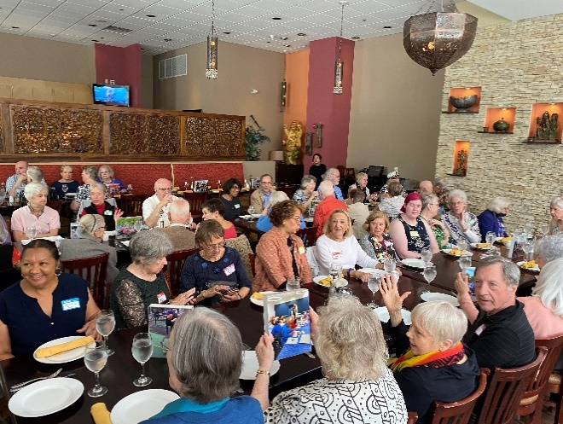

Award winners Kathy Tricky, Debby Greenstein, Ellen Spencer, Phyllis Dillinger, flanked by ED Len Bechtel and VP Peter Eicher
A large turnout for the annual anniversary and awards event, this year at Masala Arts restaurant

On May 6, 2023, Waterfront Village celebrated its seventh anniversary serving older adults in Southwest and the Navy Yard. We were pleased to see so many of our members come out for the celebration. It was a great day to recognize outstanding leaders, supporters, and volunteers.

President’s Award- For exemplary leadership in support of Waterfront Village
Ellen Spencer, Book Club
Champion’s Award- In recognition of extraordinary support of Village activities
Washington Homes Foundation, represented by Phyllis Dillinger
Debby Greenstein
Outstanding Service- For remarkable volunteer support of the Village
Kathy Trickey, Board Assistant Secretary

BOARD MEMBERS

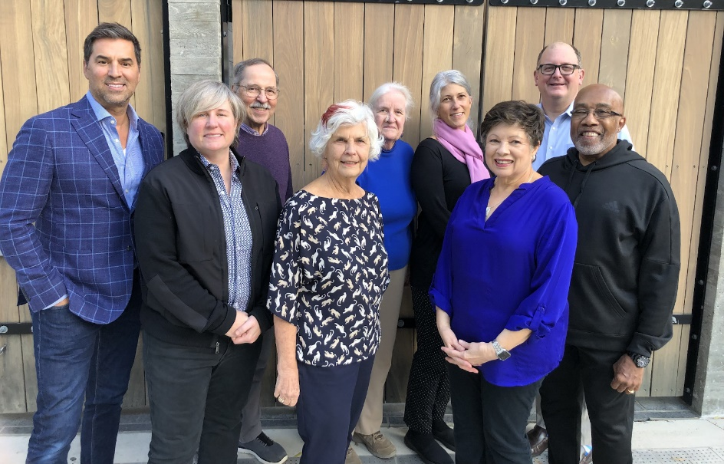
Waterfront Village Board of Directors 2023

Andy Peers
Caroline Ashe
Peter Eicher (Vice President)
Carroll Quinn (President)
Ardith Harle
Diane Renzulli (Secretary)
Judith Winston (Treasurer)
Ed Peterman
James Burleson

